**Assignment 2 : Retrieve data using join with where clause.**

Create Table:-

create table [salesman](

salesman_id int Primary key identity(1,1),

name varchar(25) not null,

city varchar(25) not null,

commission float);

create table [customer](

customer_id int Primary key identity(1,1),

cust_name varchar(25) not null,

city varchar(25) not null,

grade int not null,

salesman_id int FOREIGN KEY REFERENCES salesman(salesman_id) not null);

create table [orders](

ord_no int Primary key identity(1,1),

purch_amt float not null,

ord_date Date not null,

customer_id int FOREIGN KEY REFERENCES customer(customer_id) not null,

salesman_id int FOREIGN KEY REFERENCES salesman(salesman_id) not null);

Insert Row Command:-

insert into [salesman] values('jaivin','ahmedabad',0.12),('dina','mumbai',0.16),

('ketul','vadodara',0.15),('aayush','banaras',0.11),('dhruv','rajkot',0.19),('rajani','chennai',0.20);

insert into [customer] values ('Abhishek','ahmedabad',200,1),('yash','surat',400,2),('kevin','vadodara',800,3),

('sahil','rajkot',400,4),('mitali','banaras',500,5),

('dharam','chennai',800,2);

insert into orders values (500,'2023-02-01',1,1),(600,'2023-01-25',2,2),

(400,'2022-11-11',3,3),(800,'2002-08-12',4,4),(850,'2023-01-12',5,5);

1. write a SQL query to find the salesperson and customer who reside in the same city.Return Salesman, cust_name and city.

Ans:-

select s.name,c.cust_name,s.city from salesman s join customer c

on s.city=c.city;

Output:-

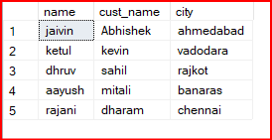

2.write a SQL query to find those orders where the order amount exists between 500 and 2000. Return ord_no, purch_amt, cust_name, city

Ans:-

select o.ord_no, o.purch_amt, c.cust_name, c.city from orders o join customer c

On o.customer_id=c.customer_id where o.purch_amt between 500 and 2000;

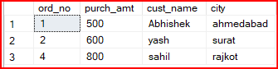Output:-

3. write a SQL query to find the salesperson(s) and the customer(s) he represents.Return Customer Name, city, Salesman, commission

Ans:-

select c.cust_name 'Customer Name',c.city 'cust city',s.city 'salesmen city',s.name 'Salesman',s.commission from salesman s join customer c

on s.salesman_id=c.salesman_id;

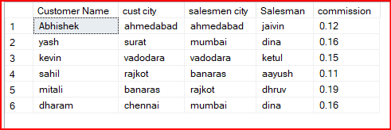Output:-

4. write a SQL query to find salespeople who received commissions of more than 12 percent from the company. Return Customer Name, customer city, Salesman,commission.

Ans:-

select c.cust_name 'Customer Name',c.city 'Customer city',s.name 'Salesman',s.commission from salesman s join customer c

on s.salesman_id=c.salesman_id

where s.commission>0.12;

Output:-

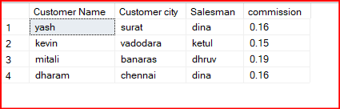

5. write a SQL query to locate those salespeople who do not live in the same city where their customers live and have received a commission of more than 12% from the company. Return Customer Name, customer city, Salesman, salesman city,commission.

Ans:-

select c.cust_name 'Customer Name',c.city 'Customer city',s.name 'Salesman',s.city 'salesman city',s.commission from salesman s join customer c

on s.salesman_id=c.salesman_id

where s.city!=c.city and s.commission>0.12;

Output:-

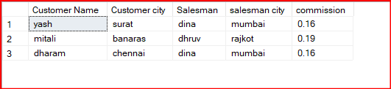

6. write a SQL query to find the details of an order. Return ord_no, ord_date,

purch_amt, Customer Name, grade, Salesman, commission

Ans:-

select o.ord_no, o.ord_date,o.purch_amt,c.cust_name 'Customer Name',c.grade,s.name 'Salesman', s.commission

from orders o join customer c

on o.customer_id=c.customer_id join salesman s on c.salesman_id=s.salesman_id;

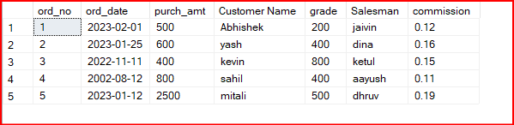Output:-

7. Write a SQL statement to join the tables salesman, customer and orders so that the same column of each table appears once and only the relational rows are returned.

Ans:-

select s.salesman_id,s.name 'salesman name',s.city 'salesman city',s.commission,c.customer_id,

c.cust_name 'custmore name',c.city 'customer city',c.grade,

o.ord_no,o.purch_amt, o.ord_date 'orderdate' from salesman s join customer c

on s.salesman_id=c.salesman_id join orders o on c.customer_id=o.customer_id;

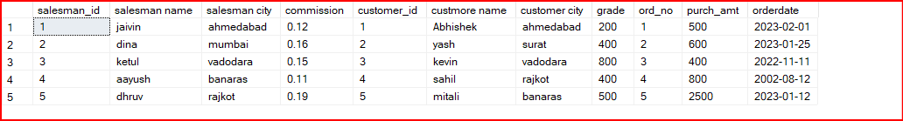Output:-

8. write a SQL query to display the customer name, customer city, grade, salesman, salesman city. The results should be sorted by ascending customer_id.

Ans:-

select c.cust_name 'customer name',c.city 'customer city',c.grade,s.name 'salesman',s.city 'salesman city'

from customer c join salesman s on c.salesman_id=s.salesman_id order by c.customer_id ;

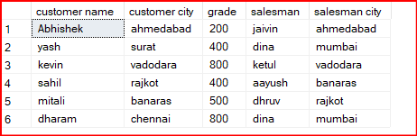Output:-

9. write a SQL query to find those customers with a grade less than 300. Return cust_name, customer city, grade, Salesman, salesmancity. The result should be ordered by ascending customer_id.

Ans:-

select c.cust_name,c.city 'customer city',c.grade,s.name 'salesman',s.city 'salesman city'

from customer c join salesman s on c.salesman_id=s.salesman_id

where c.grade<300

order by c.customer_id ;

Output:-

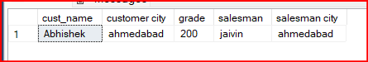

10. Write a SQL statement to make a report with customer name, city, order number, order date, and order amount in ascending order according to the order date to determine whether any of the existing customers have placed an order or not.

Ans:-

select c.cust_name 'customer name', c.city,o.ord_no 'order number',

o.ord_date 'order date',o.purch_amt 'order amount',s.name 'salesperson name',s.commission from customer c left join orders o

on c.customer_id=o.customer_id left join salesman s on o.salesman_id=s.salesman_id

order by o.ord_date;

Output:-

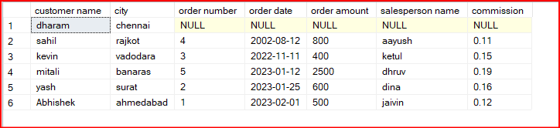

11. Write a SQL statement to generate a report with customer name, city, order number, order date, order amount, salesperson name, and commission to determine if any of the existing customers have not placed orders or if they have placed orders through their salesman or by themselves

Ans:-

select c.cust_name 'customer name', c.city,o.ord_no 'order number',

o.ord_date 'order date',o.purch_amt 'order amount',s.name 'salesperson name',s.commission from customer c left join orders o

on c.customer_id=o.customer_id left join salesman s on o.salesman_id=s.salesman_id;

Output:-

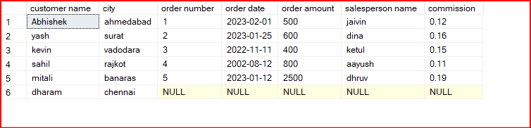

12. Write a SQL statement to generate a list in ascending order of salespersons who work either for one or more customers or have not yet joined any of the customers

Ans:-

select s.name,COUNT(c.salesman_id) 'count'

from salesman s left join customer c on s.salesman_id=c.salesman_id

group by s.name

order by COUNT(c.salesman_id);

Output:-

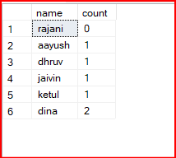

13. write a SQL query to list all salespersons along with customer name, city, grade, order number, date, and amount.

Ans:-

select s.name 'salespersons', c.cust_name 'customer name',c.city,c.grade,o.ord_no 'order number',o.ord_date 'date',o.purch_amt 'amount'

from salesman s join customer c on s.salesman_id= c.salesman_id join orders o on c.customer_id=o.customer_id;

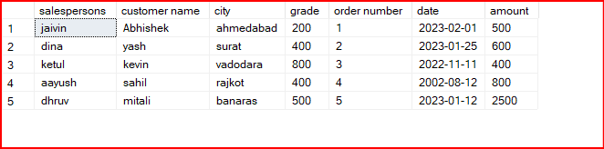Output:-

14. Write a SQL statement to make a list for the salesmen who either work for one or more customers or yet to join any of the customers. The customer may have placed, either one or more orders on or above order amount 2000 and must have a grade, or he may not have placed any order to the associated supplier.

Ans:-

select c.cust_name 'customer name',s.name 'salesman',c.grade,o.purch_amt 'purchase amount'

from salesman s left join customer c on s.salesman_id=c.salesman_id left join orders o on c.customer_id=o.customer_id

where o.purch_amt>=2000 and c.grade is not null;

Output:-



15. Write a SQL statement to generate a list of all the salesmen who either work for one or more customers or have yet to join any of them. The customer may have placed one or more orders at or above order amount 2000, and must have a grade, or he may not have placed any orders to the associated supplier.

Ans:-

select c.cust_name 'customer name',s.name 'salesman',c.grade,o.purch_amt 'purchase amount'

from salesman s left join customer c on s.salesman_id=c.salesman_id left join orders o on c.customer_id=o.customer_id

where o.purch_amt>=2000 and c.grade is not null;

Output:-



16. Write a SQL statement to generate a report with the customer name, city, order no. order date, purchase amount for only those customers on the list who must have a grade and placed one or more orders or which order(s) have been placed by the customer who neither is on the list nor has a grade.

Ans:-

select c.cust_name "customer name", c.city "customer city", o.ord_no, o.ord_date, o.purch_amt from customer c FULL OUTER JOIN orders o

ON c.customer_id = o.customer_id

where (c.grade IS NOT NULL AND o.ord_no IS NOT NULL) OR (c.grade IS NULL AND o.ord_no IS NULL);

Output:-

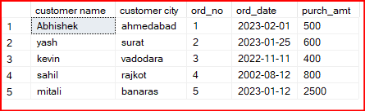

17. Write a SQL query to combine each row of the salesman table with each row of the customer table.

Ans:-

select * from salesman cross join customer;

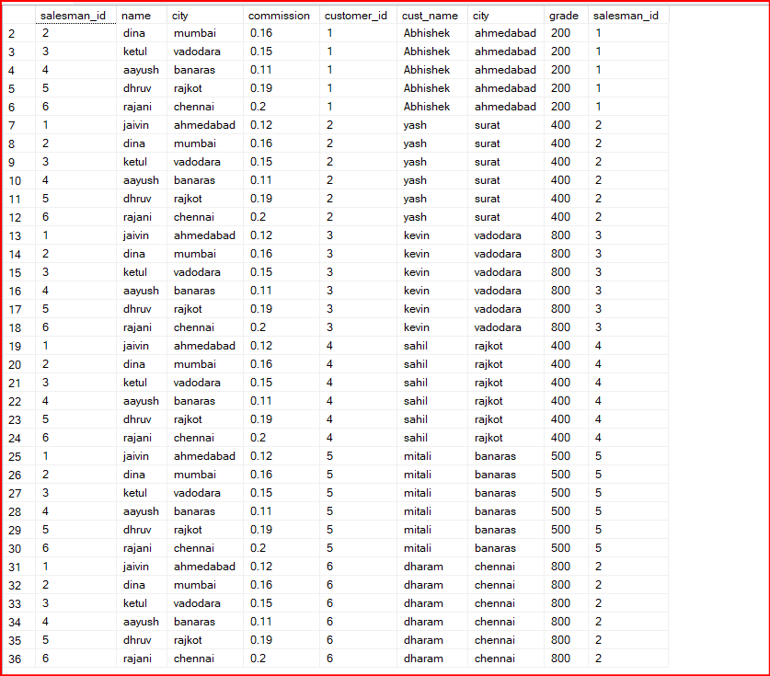Output:-

18. Write a SQL statement to create a Cartesian product between salesperson and customer, i.e. each salesperson will appear for all customers and vice versa for that salesperson who belongs to that city

Ans:-

select * from salesman s cross join customer c

where s.city=c.city;

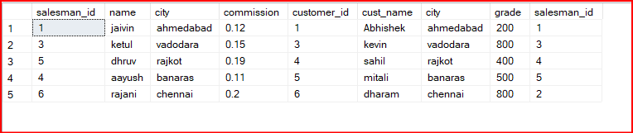Output:-

19. Write a SQL statement to create a Cartesian product between salesperson and customer, i.e. each salesperson will appear for every customer and vice versa for those salesmen who belong to a city and customers who require a grade

Ans:-

select * from salesman s cross join customer c

where s.city is not null and c.grade is not null;

Output:-

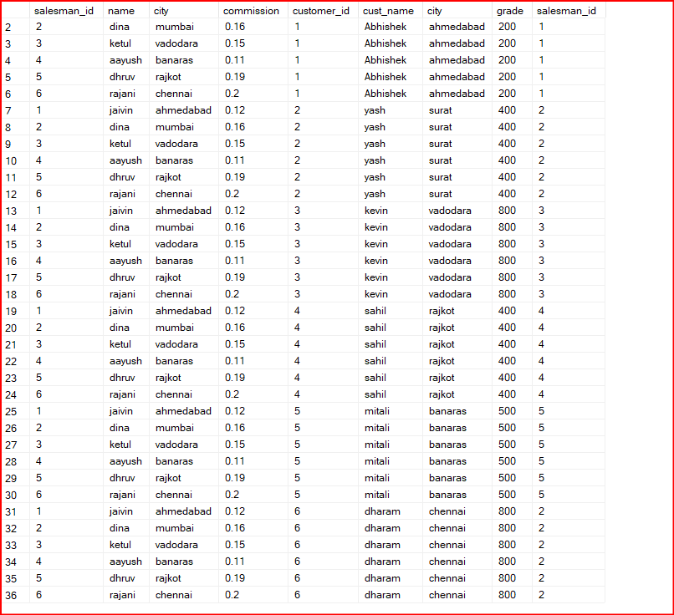

20. Write a SQL statement to make a Cartesian product between salesman and customer i.e. each salesman will appear for all customers and vice versa for those salesmen who must belong to a city which is not the same as his customer and the customers should have their own grade

Ans:-

select * from salesman s cross join customer c

where s.city!=c.city and c.grade is not null;

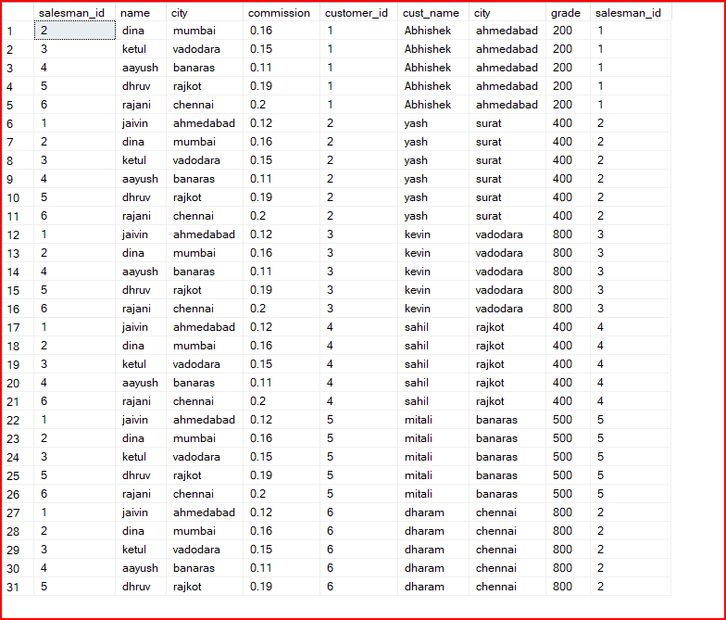Output:-